Conversational Intelligence Assistant – Voice Input, Text Output

# Executive Summary

# Our Conversational Intelligence Assistant is built to humanize machine interactions, leveraging voice recognition and audio processing that is resilient to noise and developing responses that adapt to the user. The assistant hears a user’s voice query in the world, understands natural speech, and responds with clear and contextual responses, just like a skilled sales rep or support executive.

# Our innovations include:

# • Voice to text intelligence via Whisper (small/medium/large) to accurately transcribe

# • Noise reduction preprocessing (RNNoise, WebRTC VAD) for voice clarity in a noisy environment,

# • Context/learning from audio, FAQ, and domain data using RAG models,

# • Ambiguity resolution followed by fallback using real-time confidence scoring, so no questions are left unasked.

# This system is built for scale, easily adaptable to retail, enterprise support, and customer engagement platforms. It will enable quicker product discovery, smoother support experience, and learn intelligently from human conversations over time.

# Problem Understanding and Scope

# Conversational interaction is instinctive to users but very difficult for machines to replicate--and especially difficult in unpredictable environments like retail stores or customer service centers. It is challenging for machines to:

# o Decode unclear voice inputs or noisy environments

# o Understand vague, multi-intent, or ambiguous requests

# o Maintain the same high quality, consistency, and user contextual awareness with a non-human response.

# Target user types are customers seeking product information, sales agents who need quick back end support, or users who rely on the Web and/or accessible features.

# Scope:

# - Build a real-time voice-to-text process that minimizes latency

# - Ensure relevance of response and clarity of response through retrieval and context learning

# - Minimize user frustration by providing backoffs in a graceful manner

# - Allow machines to continuously self-learn based on prior interactions as well as updates in product/faq information

# Knowledge Strategy

# To allow intelligible and domain aware output and response, our assistant will learn and adapt through:

# A. Audio Learning and Preprocessing

# - Noise Suppression: Remove noise from the raw voice input (the audio) prior to to transcribing the voice into unstructured text with RNNoise, and WebRTC Voice Activity Detection (VAD).

# - Whisper Model: Convert the cleaned speech, with the Whisper model (small, medium, large), depending on storage and speed requirements, into unstructured text.

# 

# B. Post-Transcription Correction

# - DistilBERT fixes domain-related transcription errors (for example, converting "foam" to "phone" in the context of an electronics store).

# - Includes contraction expansion and fixing grammar of informal inputs.

# C. Data Sources

# - FAQs: Structured question-answer pairs in a FAQ, indexed using our Elastic Search capabilities.

# - Web Knowledge: Product data, descriptions, and reviews scraped, and indexed and encoded semantically.

# - Historical Chat Logs will be used in reinforcement learning so subsequent responses can be adjusted.

# 

# D. Reinforcement Learning, and safety

# - KL-Divergence based optimization will ensure the assistant is evolving to allow the agent to better align with the human preferred output over time.

# - Proximal Policy Optimization (PPO) will be used to ensure any new policy increments involving learning, occur in a safe manner and are relative incremental. This will reduce the likelihood of reward hacking i.e., when the assistant might find a useful shortcut, to exploit the reward associated with that signal, rather than providing user value.

# Conversation Design

# A good voice assistant must not only be able hear — it must be able to understand.

# A. Voice Input Handling

# ➢ Whisper transforms any spoken language to text after performing preprocessing.

# ➢ Domain-specific vocabulary is adjusted based on fine-tuning.

# ➢ Low-quality input is cleaned and filtered to remove undesired noises.

# B. Understanding Ambiguous Queries

# ➢ Ambiguity Detection relies on word-overlap scoring (i.e., if words matched are <20%, it is likely out of context).

# ➢ Rasa NLU tracks intent confidence (< 0.7 will trigger a fallback).

# C. Response Generation

# ➢ T5 transformer generates responsive, human-like replies by producing directly from:

# o Chat history context.

# o FAQ content retrieval.

# o Knowledge embeddings.

# D. Fallback Triggers

# When the assistant is lacking clarity, one out of two fallback trigger is taken:

# ➢ Make the user clarify the information being requested (“can you clarify which product you were referring to?).

# ➢ Escalate to a human operator (optional phase).

# E. Human Alignment - The HHH Framework

# ➢ All conversational outputs will be filtered using the Helpful, Honest, Harmless (HHH) framework.

# o Helpful: This input will need to assist the user make constructive progress toward their goal.

# o Honest: To ensure that hallucination was prevented, and no misleading or factually incorrect responses were provided.

# o Harmless: avoid producing biased, unsafe or inappropriate reponses.

# Strategizing human alignment explicitly advances trust, equity and responsible AI use with any mode of deployment.

# Technical Architecture

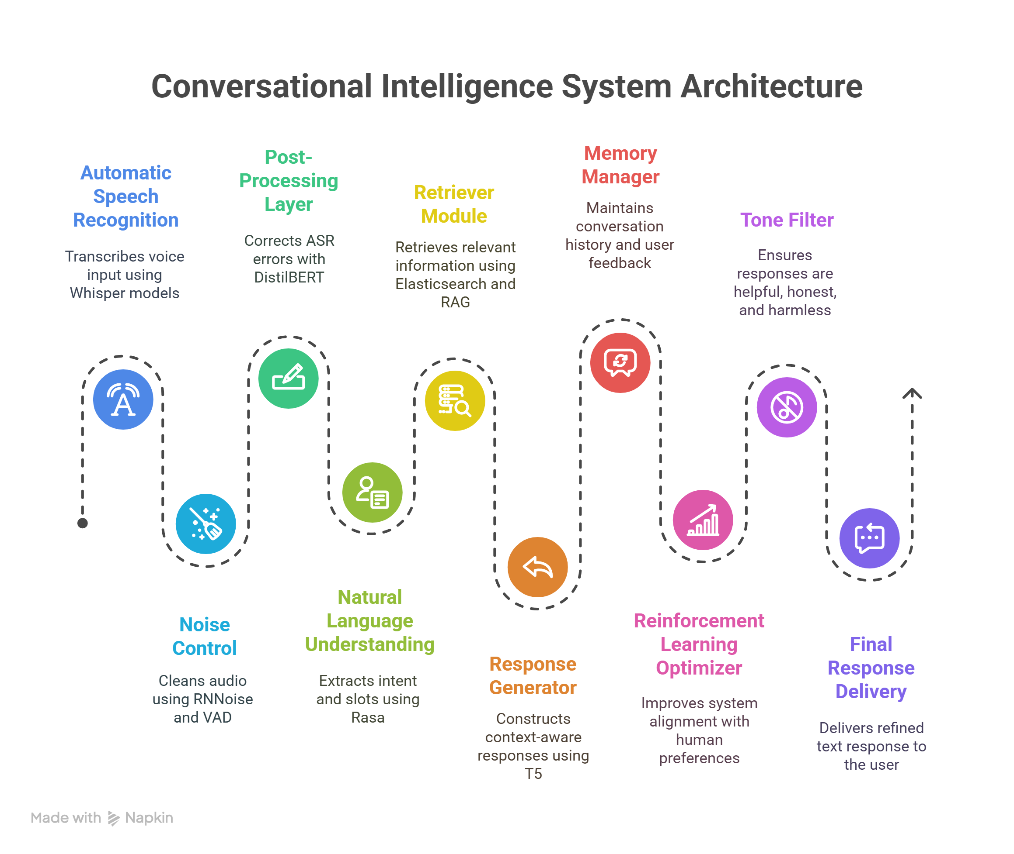

# Implementation Plan

**- Phase 1: Prototype**

**- Integrate Whisper + RNNoise pipeline**

**Set up the core voice input system by integrating noise suppression (RNNoise) with Whisper ASR for accurate transcription.**

**- Develop T5 response logic over static FAQ database**

**Use a T5 model to generate responses from the preloaded FAQ dataset to simulate early conversation capability.**

**- Deploy on local or testing cloud platform.**

**Deploy the prototype locally or on a test cloud environment to test the pipeline end-to-end.**

**- Phase 2: Alpha Build**

**- Integrate Rasa for fallback and multi-intent detection**

**Enable intent recognition and slot recognition and fallback prompts for unclear or low-confidence queries.**

**- Connect Elasticsearch + RAG for dynamic answer fetching**

**For dynamic answer fetching using semantic search, use retrieval-augmented generation. Self-authored content can be used to ask follow-up questions.**

**- Add chat history tracking**

**Store past user interactions to enable memory, personalization, and multi-turn conversation.**

**Phase 3: Beta Build**

**- Add reinforcement learning loop with KL-Divergence**

**Refine sample responses using user feedback through a reinforcement learning algorithm, while constraining function drift using KL regularization.**

**- Tune fallback logic and personalization capabilities**

**Enhance fallback prompts in certain cases and changes to how responses are personalized based on the user's previous interactions or behavior.**

**- Start pilot in the real world in intended domain**

**Assess performance of the assistant with real users in intended environment (e.g., in retail, support) and collect feedback regarding usage performance.**

**Phase 4: Deployment Plan**

**- Cloud Host, or else, Vercel or AWS Lambda**

**Implement cost-effective and globally available on-demand serverless infrastructure that can scale with usage.**

**- Containers: Each can be running in dockerized microservices**

**Package each module (ASR, NLP, RAG) as a standalone container, deploying them can be done independently of the others, which leads to modularity and maintainability.**

**- Monitoring: Log, and feedback loop for improvement**

**Implement logging, analytics, and error tracking to assess system performance, and feedback the learning loops.**

**- Modularity: Plug-and-play architecture for ASR/NLP/RAG endpoints**

**Build the system in such a way that allows for any of the core components (ASR/NLP/RAG) to be swapped out or upgraded without disturbing the pipeline.**

# Innovation Highlights

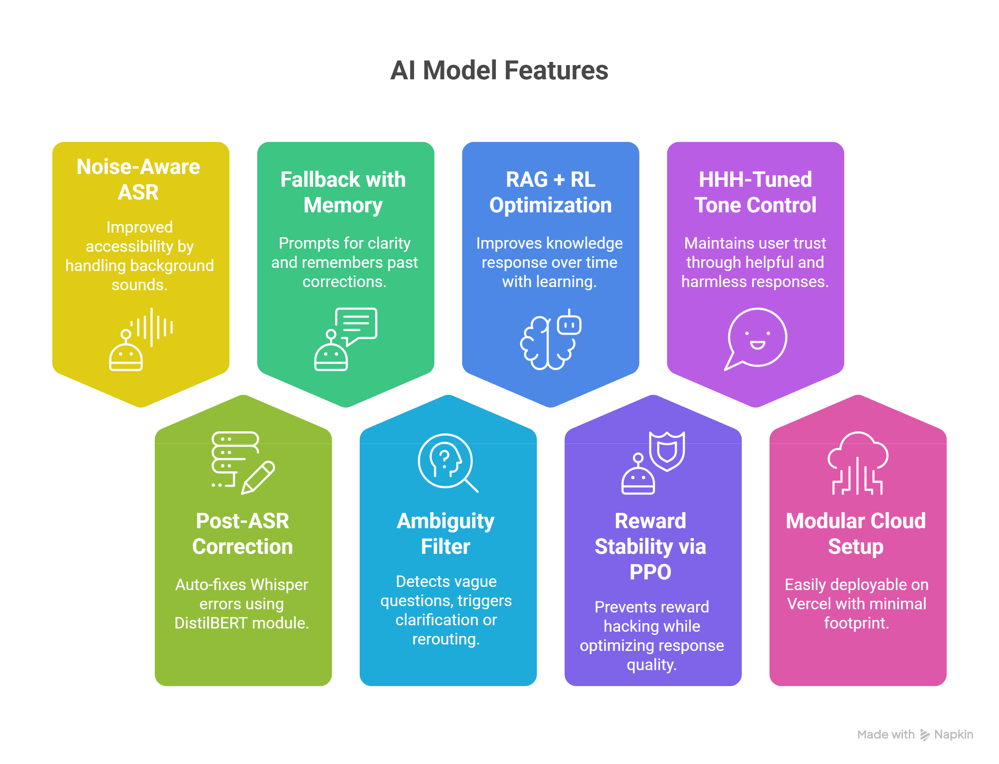

# Team Information

**Meet Jethwa - Project Manager & NLP Lead**

**Supervises project execution, coordinates across all modules and leads ASR-NLP integration. Jethwa is also primarily responsible for the Whisper fine-tuning, T5 response logic, and matching the conversational model to the domain needs.**

**Shubham Vishwakarma - Technical Architect & Backend Lead**

**Designs and builds the back end of the microservices architecture including, Reinforcement learning, Elasticsearch integration, and RAG pipelines. He is also the primary responsible person to the deployment set up with Docker, Vercel/AWS.**

**Dhiraj Nair - Knowledge & Retrieval Engineer**

**Responsible for data pipelines to ingest and index FAQs - product databases and web content; configuration of Elasticsearch and the embedding-optimal query strategies that would allow for accurate retrieval of knowledge.**

**Jeet Nakrani - Frontend Developer & UX Engineer**

**Responsible for the voice-enabled user interface and display for the conversation, and ensuring real-time interactions and accessibility. He is also partially responsible for integrating the ASR outputs and fallback prompts into the frontend flow.**